COURSE CODE: CSA1717 COURSE NAME: ARTIFICIAL INTELLIGENCE
NAME: H NUHA FATHIMA REG NO: 192524244

LAB PROGRAMS
- Circulating 4 Variables
CODE:
a = 10
b = 20
c = 30
d = 40
a, b, c, d = d, a, b, c
print("After circulation:")
print(a, b, c, d)

OUTPUT SCREENSHOT:

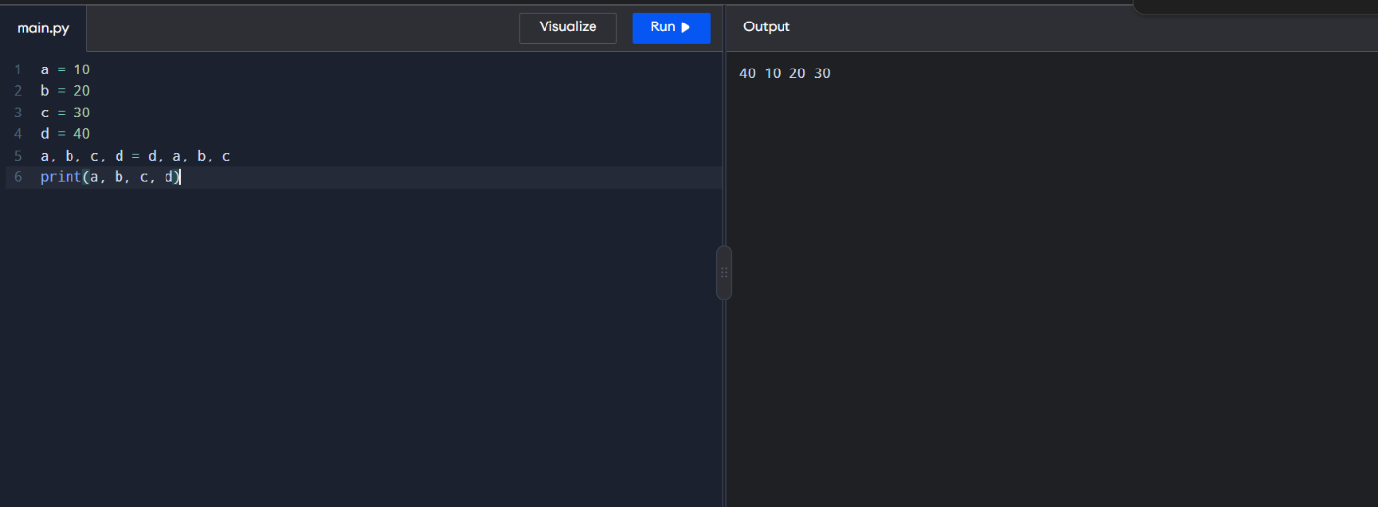

- Circulating 3 Variables

CODE:
a = 10
b = 20
c = 30
a, b, c = c, a, b
print("After circulation:")
print(a, b, c)

OUTPUT SCREENSHOT:
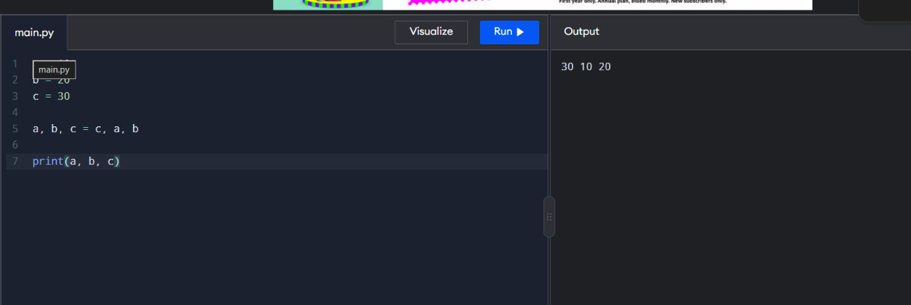

3.Shortest Distance
CODE:
import math
x1 = 2
y1 = 3
x2 = 5
y2 = 7
distance = math.sqrt((x2 - x1) ** 2 + (y2 - y1) ** 2)
print("Shortest distance =", distance)
OUTPUT SCREENSHOT:

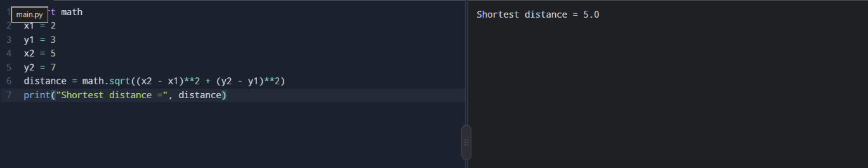

4.Swapping Two Numbers
CODE:
a = 10
b = 20
print("Before swapping:", a, b)
a, b = b, a
print("After swapping:", a, b)

OUTPUT SCREENSHOT:
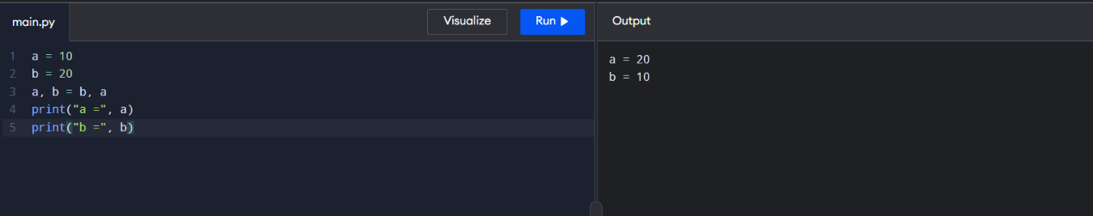

5.if-else
num=4
if num%2==0:
print("EVEN")
else:
print("ODD")
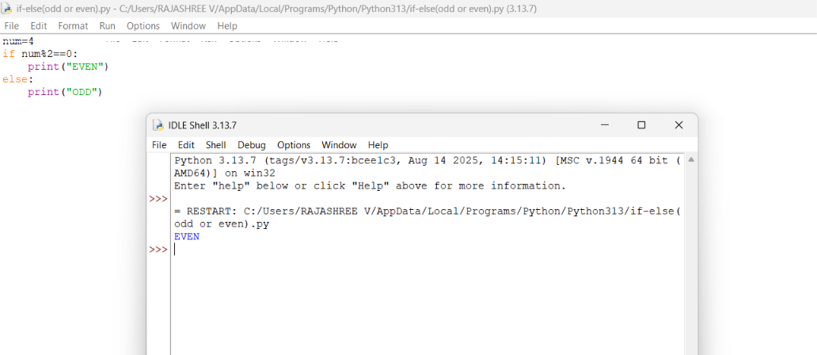

6.if-elif-else
score=85
if score>=90:
print("Grade A")
elif score>+75:
print("Grade B")
else:
print("Grade c")
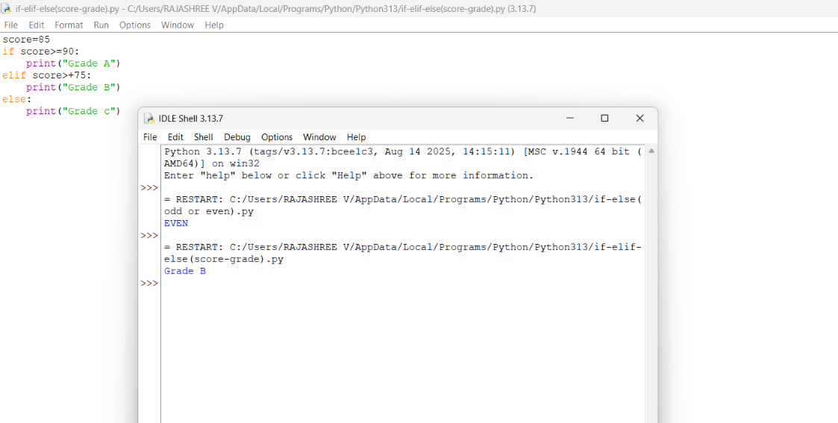
7.while loop
Count=1
While count<=5:
Print(count)
Count+=1

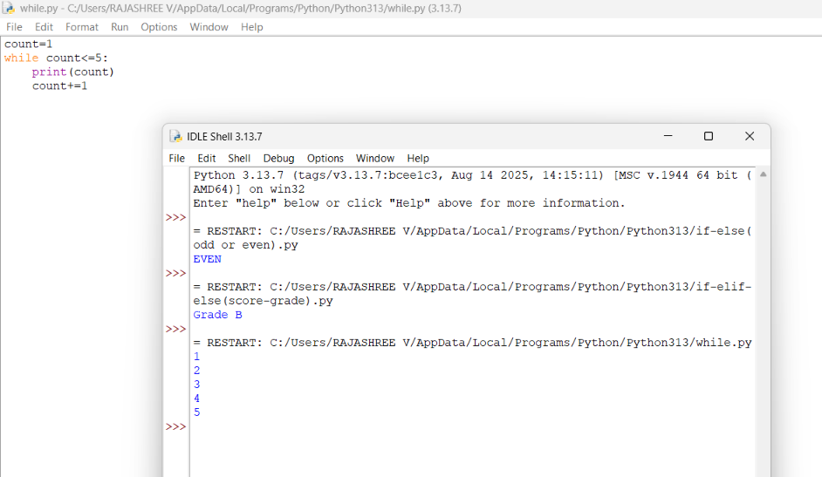

8.for loop
for i in range(5):
print(i)
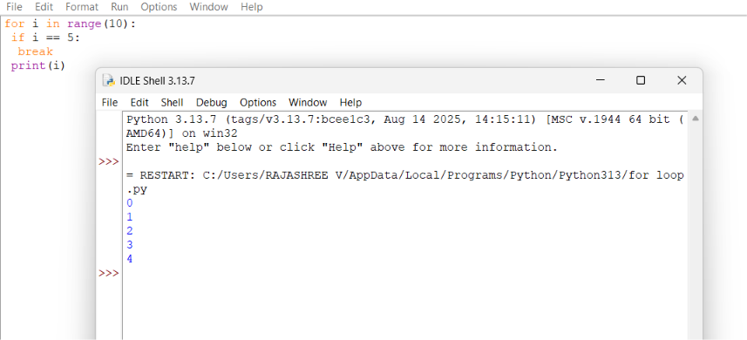
9.for loop:
for i in range(10):
if i == 5:
break
print(i)

10.print the following using loops

a.1 2 3 ……100
using for loop:
code:
for i in range(1,101):
print(i)
(or)
for i in range(1,101):
print(i,end=" ")

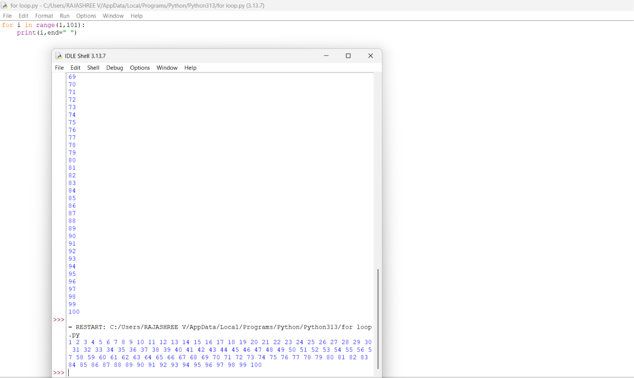
Using while:
Count=1
While count<=100:
Print(count,end=” ”)
Count+=1

b.100 99 ………………………….. 1
using for loop:
for i in range(100,0,-1):
print(i,end=" ")

using while loop:
Count=100
While count>=1:
Print(count,end=” ”)
Count-=1

c.1 3 5…………………………………..99
using for loop:
for i in range(1,101):
if i%2!=0:
print(i,end=" ")

using while loop
Count=1
While count<=100:
If count%2!=0:
Print(count,end=” ”)
Count+=1

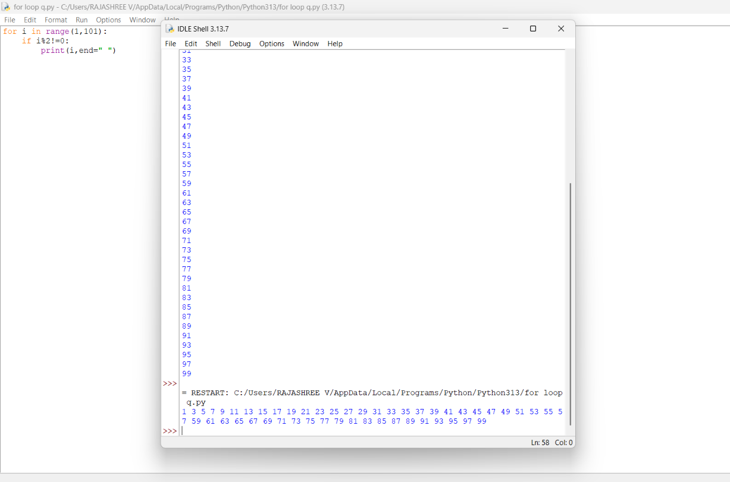

D.99 97 95 ………………………………….1
using for loop:
for i in range(100,0,-1):
if i%2!=0:
print(i,end=" ")

using while loop
Count=100
While count>=1:
If count%2!=0:
Print(count,end=” ”)
Count-=1
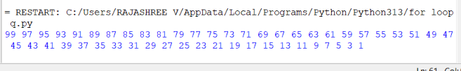

E. 2 4 6………………………………100
using for loop:
for i in range(1,101):
if i%2==0:
print(i,end=" ")

using while loop
Count=1
While count<=100:
If count%2==0:
Print(count,end=” ”)
Count+=1

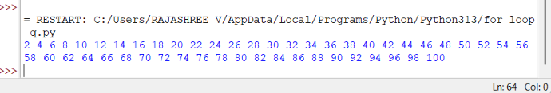

F . 100 98 96 ………………………………… 2
using for loop:
for i in range(100,0,-1):
if i%2==0:
print(i,end=" ")

using while loop
Count=100
While count>=1:
If count%2==0:
Print(count,end=” ”)
Count-=1

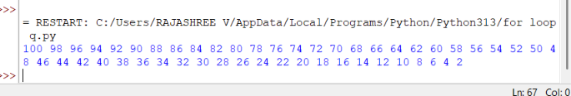

G. 10 20 30 ………………………………..100
using for loop:
for i in range(1,101):
if i%10==0:
print(i,end=" ")
using while loop
Count=1
While count<=100:
If count%10==0:
Print(count,end=” ”)
Count+=1

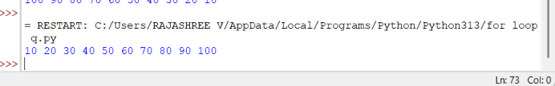

H.100 90 80 ……………………………….. 10
using for loop:
for i in range(100,0,-1):
if i%10==0:
print(i,end=" ")

using while loop
Count=100
While count>=1:
If count%10==0:
Print(count,end=” ”)
Count-=1

